Parking Information for the Continental League Meet
Wed. Oct 11th at 3:30 pm

Bus and Van Parking: (Red arrow on map) All buses and vans must park at Sedalia Elementary (same place as for the Polson Ranch Invitational). Please direct your bus drivers to right turn at Rio Grande Avenue. We will have volunteers at the junction of Rio Grande and Hwy 67 to direct buses. Buses will not be allowed to enter the Ranch. Once at the school you will be directed as to where to park. Even if you have a one-way bus you will drop off runners at Sedalia Elementary.

Car Parking: Cars will be directed to turn right on Douglas Avenue off Hwy 67 and then left into the field where the cars will be parked. (Blue arrow on map).

Leaving the Meet: If you are leaving the meet and are heading north on Hwy 85 (Santa Fe) please turn left on Plum Ave from Hwy 67 (Manhart Ave). Plum Ave will turn into Peterson Rd which parallels Hwy 85 (Santa Fe). After a couple of miles Peterson Ave ends at Airport Rd. Turn right on Airport Road and then left on to Hwy 85 (Santa Fe).

Please be patient leaving the meet and be respectful of Mr. Polson’s property. He has been very generous in his support of our sport!

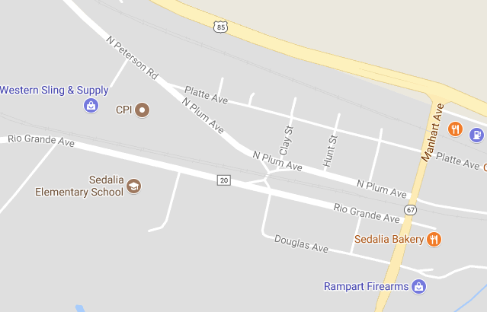
Car Parking
Bus Parking

